University of New Hampshire

Analysis of the Magnus Effect on a Cylindrical Airfoil

Project Proposal

Team Members -

Zhangxi Feng, Simon Popecki, James Skinner

ME 646

Professor Todd Gross

Due – 4/13/2017

# Objective

The goal of this experiment is to compare the effects of the rotational speed, diameter, and surface roughness of a rotating cylinder on the resulting lift force and drag force under the Magnus effect. The cylinder will be placed inside the test section of an indoor open return wind tunnel with the air flowing at a constant velocity. The cylinder will ride on bearings around a stationary steel shaft of ½” diameter. The bearings and shaft will be indirectly driven by a motor mounted to the shaft with which we can measure the lift and drag forces experienced by the cylinder through the support beam.

# Methodologies

## Analytical

The Magnus effect is predicted using the Kutta-Joukowski theorem1:

Where the lift force on the cylinder, $F$, is linearly related to density of the fluid, $ρ$, velocity of the fluid, $υ$, and the strength of the vortex as a result of the rotation, $G$. The vortex strength is given by:

$$G={\left(2πr\right)}^{2}s$$

Where $s$ is the rotation of the cylinder in RPS and $r$ is the radius of the cylinder.

Knowing the velocity and density of the fluid and controlling the rotation speed and cylinder radius, we can measure the force experienced by the cylinder using the AFA2 Single Component Lift and Drag Balance and plot the measured values against the diameter and rotational speed to compare their respective effects and how well does the Kutta-Joukowski theorem predict the measurements.

We also plan to use sandpaper as a rougher surface to measure the effect of surface roughness on the lift and drag forces.

## Experimental

Our theoretical analysis shows that a resulting lift force of 100 N will lead to 6 mm deflection in the supporting beam. Therefore, we set our maximum cylinder diameter to be 7.5 cm at 9000 RPM and an air flow rate of 5 m/s. On the other hand, the force becomes immeasurably small if the diameter is less than **X**. The limits give a **X**:1 ratio of maximum and minimum diameters to give a sufficiently large range for analyzing a relationship between the variables. The rod may be hardened such to decrease deflection.

## Evaluation

We are expecting difficulty to successfully record experimental data for a rotating airfoil using the student wind tunnel. With this in consideration when designing our experimental set-up, we will strive to successfully acquire experimental data in the wind tunnel with our airfoil that we can then go on to analyze and compare to our expected calculations for the expected conditions.

# Equipment/Test Facilities/Support Needed

We will use cardboard to create our experimental airfoils. The cardboard’s surface will be the smooth surface, then sandpaper will be placed over the entirety of the outer surface on the airfoil (perpendicular to the flow of air) to simulate a rough surface. The airfoil will rotate about a steel rod which intersects the entirety of the airfoil and has wooden plugs on each opening of the airfoil to secure it to the force balance. The rotation will be powered by an electrical motor (MEGA ACn 16/15/8) which drives a bronze collar on the shaft which connects to a wooden disc on the side of the airfoil. Mechanical power transmission may be employed via a #25 roller chain (already owned) or a wheel driving the bronze collar directly. The motor will be mounted to a steel bar, which is welded to a shaft collar. Any potential spending will be used on the steel rod, collar, cardboard, wood, hardware, and bearings. We will use the University of New Hampshire Mechanical Engineering wind tunnel to conduct our experiment. Assistance may be necessary to properly operate the student wind tunnel.

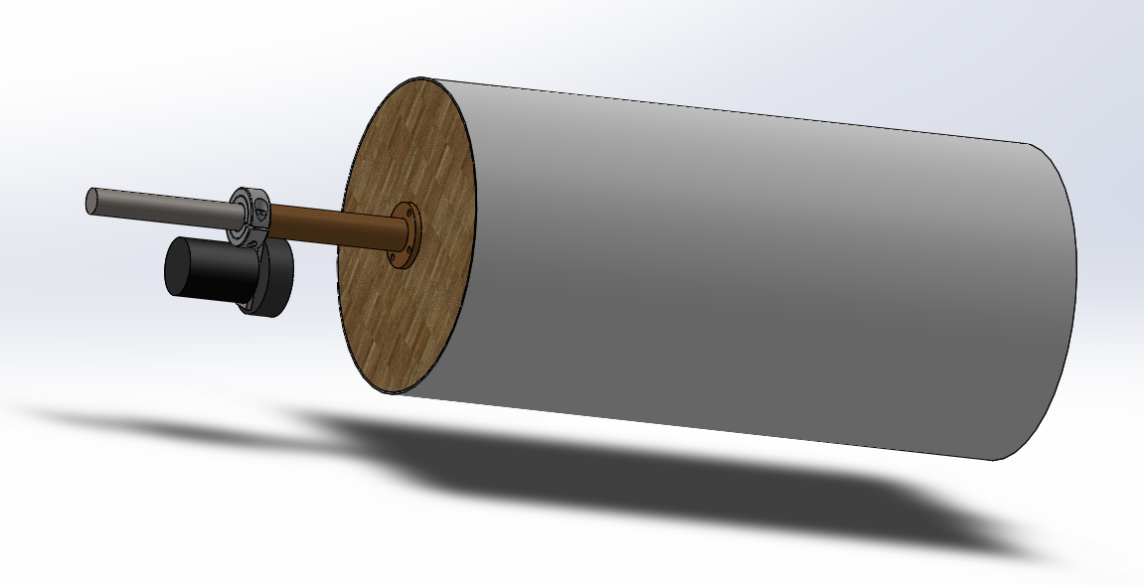

# Schedule

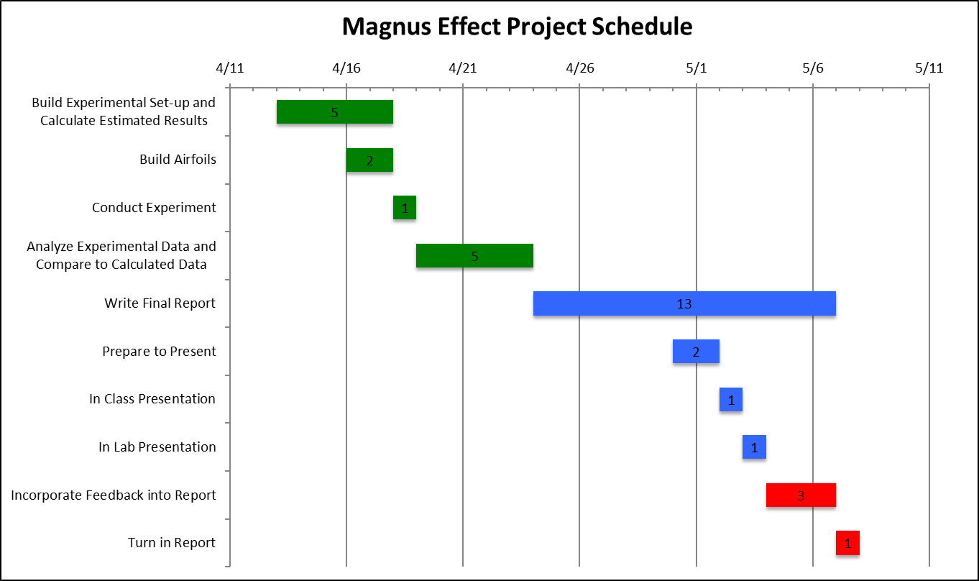

# References

1Hall, Nancy, (2015), “Lift of Rotating Cylinder,” NASA Glenn Research Center, last accessed on April 13, 2017, from: https://www.grc.nasa.gov/WWW/K-12/airplane/cyl.html